1. Top 3 performing cities by total trips –

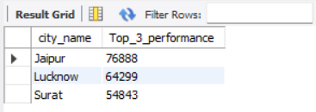

1. Bottom 3 performing cities by total trips --

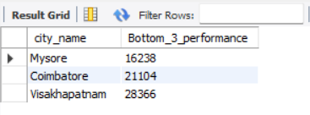

1. Average fare per trip by city; highest & lowest –

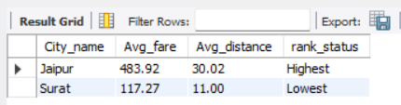

1. Average Ratings by city & passenger type

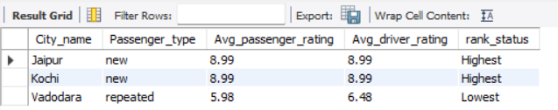

1. Peak and Low Demand Months by City

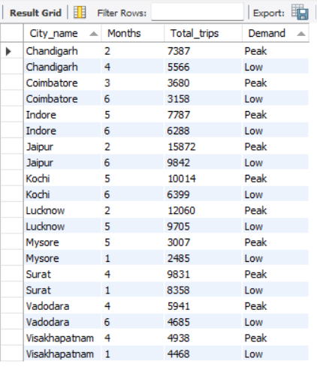

1. Weekend v/s Weekday Trip Demand by City

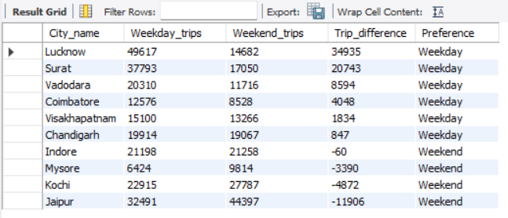

1. Repeat Passenger Frequency and City Contribution Analysis

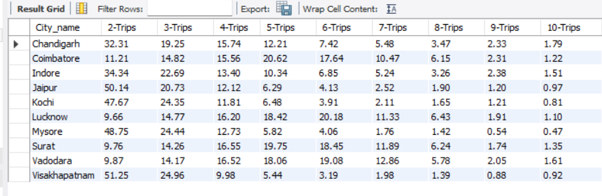

1. Monthly Target Achievement Analysis for Key Metrics

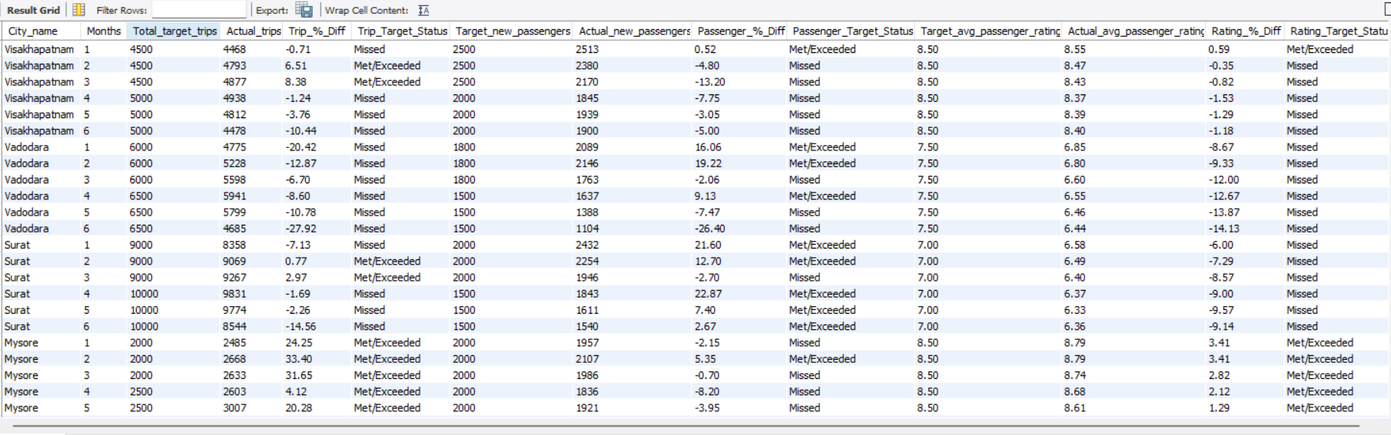

1. Highest and Lowest Repeat Passenger Rate (RPR%) by City and Month
   1. Analyse the Repeat Passenger Rate (RPR%) for each city across the six-month period. Identify the top 2 and bottom 2 cities based on their RPR% to determine which locations have the strongest and weakest rates.

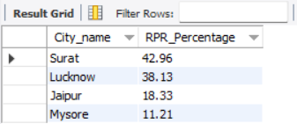

* 1. Similarly, analyse the RPR% by month across all cities and identify the months with the highest and lowest repeat passenger rates. This will help to pin-point any seasonal patterns or months with higher repeat passenger loyalty.

